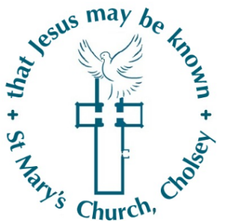
Reporting a Safeguarding Concern Form
St Mary’s Church Cholsey

Please fill this form in and give it to the Safeguarding Officer.
Be as factual as possible.
Write down all the details that you remember.
SAFEGUARDING TEAM DETAILS
Safeguarding Officer | Alex Hammond
Contact Details | 07966458256

YOUR DETAILS
Name:
Date:
Telephone number:
Email address:

WHO?
Name of person you are concerned about:
Do they know that you are raising this concern?
Are they an adult or a child?
Time and date of disclosure:

WHAT?
What happened that concerned you?
WHERE?
Where did this happen?

WHEN?
When did this concern happen?

Date of completion:

Signature of person completing the form:

