My Dear Friends,
We are living in extraordinary times, such as most of us have never seen before in our life-time. Many are fearful of the effects of the corona virus, whether it is for our own health or the health of more vulnerable loved ones, or fear of the economic consequences of the Government’s strategy to limit the effects of the outbreak.
Recently, I was reflecting on Psalm 46 which says: ² Therefore we will not fear, though the earth give way and the mountains fall into the heart of the sea. Certainly, that’s what it feels like at the moment – as if our whole landscape has changed, and the things we have always taken for granted as being permanent fixtures in our lives have just given away and disappeared for the time being.
In St Paul’s famous passage on love, from 1 Corinthians 13, he says that whatever else might disappear, three things remain: faith, hope, and love. For the Psalmist as one who believed in God, the remedy for fear when everything around him was giving away, was the first of these - faith: to remind himself that God was in their midst as a people. He knew God was a refuge, a fortress and someone who gives us strength and help in time of trouble. Famously when Jesus’ disciples were in a boat on the Sea of Galilee with Jesus who was fast asleep, and a huge storm blew up threatening to overwhelm the boat, they woke him up with the words: “Master don’t you care that we are all about to drown?!”. Jesus, woke up and replied by asking them “Where is your faith?” He then promptly brought the storm to an end. I do believe that this corona virus storm will be brought to an end. But maybe Jesus is asking us: “Where is your faith?”
The second remedy for fear is hope. Even though the church cannot not hold public services at present, this will not stop us at Easter next month celebrating in different ways the great hope of new life and resurrection. Easter reminds us that however dire things might seem God has the power to overcome the greatest darkness. As Desmond Tutu once said: ““Good is stronger than evil; love is stronger than hate; light is stronger than darkness; life is stronger than death. Victory is ours, through him who loves us.”
This brings us to the third and perhaps most powerful remedy against fear, which is love. The Apostle John wrote that perfect love casts out fear. He was talking about the need for us to be aware of how much God loves us, but the more we love one another, our neighbour, the most needy in our community, the more we will be aware of the love God has for each one of us.
May this time of crisis be a time when we learn even more to look out for each other, to show love and compassion; in doing so we shall discover a remedy – along with faith and hope – against any anxiety or fear.
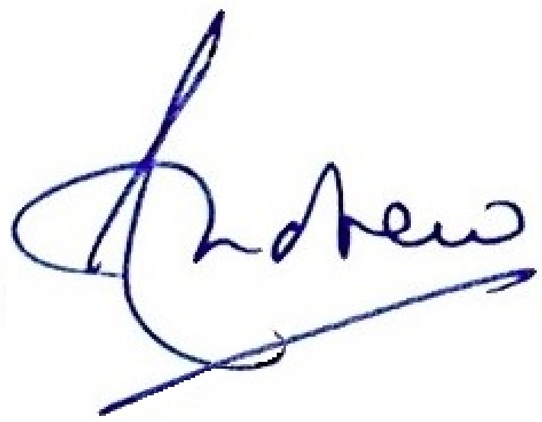
With warmest regards,

Andrew Petit, Vicar of Cholsey & Moulsford andrewpetit@virginmedia.com Tel: 01491 651216

If you would like pastoral or spiritual support, please do not hesitate to contact Andrew.

